  Curriculum Map  Reception 2025 - 2026 | Autumn |  | Spring |  |  | Summer
 | Marvellous Me | Special Delivery | Our Wonderful World |  |  | Amazing Animals | Exploring secrets of the wild
 | Autumn 1 | Autumn 2 | Spring 1 |  | Spring 2 | Summer 1 | Summer 2
 | All about me | Post Office, Santa’s workshop and the Nativity | New Year Celebrations | Arctic | Ocean Explorers | Farm animals and chicks | The Very Hungry Caterpillar, minibeasts and growing plants.
PSHCE | Being Me in My World  'Who am I and how do I fit?' | Celebrating Difference  Respect for similarity and difference. Anti-bullying and being unique | Dreams and Goals  Aspirations, how to achieve goals and understanding the emotions that go with this |  | Healthy Me  Being and keeping safe and healthy | Relationships  Building positive, healthy relationships | Changing Me  Coping positively with change
Visits and Special Events | - Staggered Start  - Visit from Fire Service (dependant on service availability) | - Official Road Safety Week  - Walk to the Post Box  - Christmas Production | - Chinese New Year – 17th Feb ( Year of the Horse)  - Chinese Banquet  - Polar Bear talk from YWP |  | - Mothers’ Day – March 30th | - Chicks in an incubator in class | - Father’s Day – June 21st
Career Aspirations | Doctor/Therapists | Postal Worker | Explorer |  | Marine Biologist | Farmer/Vet | Entomologist
Book focus | 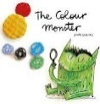  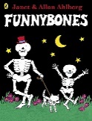  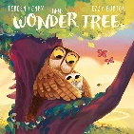  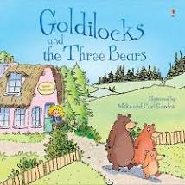  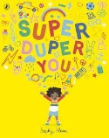  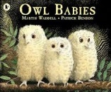 | 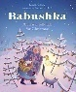  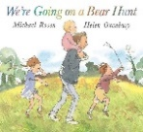  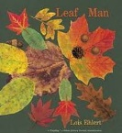  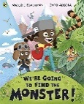  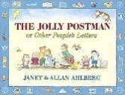  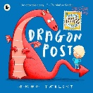 | 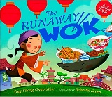  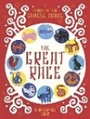 | 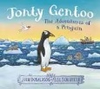  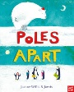 | 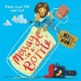  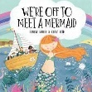  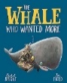  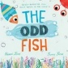 | 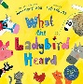  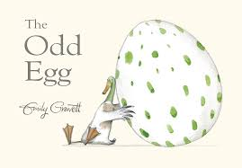  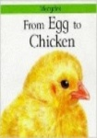  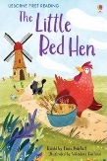  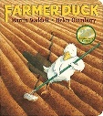 | 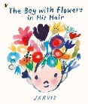  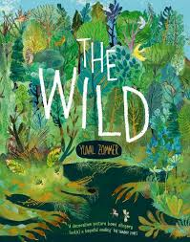  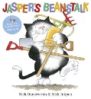  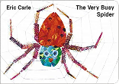  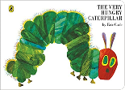
English  Reading | Oxford Reading Tree stories  Fiction – recognising familiar characters and relating to who is in our family. Reliving everyday experiences and talking about past and present events.  Super Duper You  Fiction – Discussion text - what do we like? What don’t we like? Who are we?  Goldilocks and the Three Bears (warning story)  Fiction – Traditional tales  identifying features/characters of the story.  Owl Babies (losing story) Fiction – Repetitive language, sequencing the events.  Discussion text - drama (empathy)  The Wonder Tree  Fiction – comparison story to The Owl Babies. | We’re Going on a Bear Hunt / We’re Going on a Monster Hunt  Fiction – Repetitive language Collaborative group work idea generation for a new chapter of a familiar story.  Dragon Post  Fiction – persuasion text, discuss the language used to persuade. Features of letters.  Leaf Man  Fiction – Discussion text - Autumn description – making a leaf character. What will your man look like?  Jolly Postman (Journey Story)  Fiction – Familiar settings and characters | The Great Race: The Story of the Chinese Zodiac (Fantasy/Journey story)  Fiction – sequencing  The Runaway Wok (losing story) | Pole Apart  Fiction – journey story.  Travelling to different places. Discussions around descriptive language.  Jonty Gentoo  Fiction – Journey story - compare to Poles Apart  Polar Bear Fact file - TFW  Information text – facts around an animal. Grouping facts into categories. | Message in a Bottle –  Discussion text – what would we like in a friend? Advert for a friends  We’re off to meet a mermaid  Non-fiction – fact file of a sea creature  The Odd Fish  Fiction –persuasion - look after our seas  Link to non-fiction explanation texts around protecting the animals and oceans.  The Whale who wanted more  Fiction – discussion text – being a good friend | Egg to Chicken  Non-fiction – Information texts, fact file for Chicken  – explanation - diary of the life cycle  Non-fiction – explanation – observations of chicks  Little Red Hen  Fiction – Places with familiar settings  SEMH – managing feelings and behaviour  Farmer Duck (change story)  Fiction – retelling  What the Ladybird Heard  Fiction text – familiar setting, rhythm and rhyme story. | The Very Hungry Caterpillar by Eric Carle  Fiction – sequencing – days of the week  Non-fiction – explanation – life cycle of a caterpillar  Jack and the Beanstalk (fantasy story)  Fiction – traditional Tales  Jaspers Beanstalk  Fiction – sequencing – days of the week, compare to The Very Hungy Caterpillar.
Writing | Mark Making – practise writing lines in different direction ( up, down, left, right, diagonal)  Follow line tracks  Name writing  Correct pencil grip  Witch in Training  Potion writing (segmenting to write words)  Making birthday cards for peers / family. | We’re going on a bear hunt  Adult to scribe the new verse of the story  Persuasive text – Write a letter to Father Christmas  Recount writing – Our journey to the post box. | The Chinese Zodiac Story  Retelling the story of the Lunar New Year - write sentence to match each picture.  Writing in a list ( Chinese menu) to go with our banquet | TFW – Polar Bear Fact File  Labelling a picture of a polar bear  Writing key facts to explain what we know about an animal | Message in a Bottle  Persuasive text - advert for a friend. What would a friend need to be?  We’re off the meet a mermaid  Label a mermaid – descriptive writing. What will the mermaid be like? | Egg to Chicken  Chick observations, label a diagram. Writing facts about chickens / eggs  Farmer Duck ( change story)  Descriptive writing – what would the duck do? Write another job for the duck based on the story | Jasper’s Beanstalk  Instruction texts – write a set of instructions on how to plant a seed to grow a plant.  The Very Hungry Caterpillar –  Sequencing and retelling. Re write a familiar story.
Phonics – Writing | Write each grapheme as the sound is learnt – use Phonics mantra’s to ensure each letter is taught with correct letter formation
Phonics | Level 1+ sounds  s, a, t, p, i, n, m, d, g, o, c, k, ck, e, u, r, h, b, f, ff, l, ll, le, ss |  | Level 2 sounds  j, v, w, x, y, z, zz, qu, ch, sh, th, ng, dge, ,ve, wh, cks, tch, nk, ai |  |  | Level 3 sounds  ee, igh, oa, oo, oo, ar, or, ur, ow, oi, ear, air, er, er, ue, ue, ure, ture
Mathematics (number) | - Match sort and compare – matching, identifying sets, sorting and comparing amounts  - It’s me 1, 2, 3 – find, subitise, represent and composition of 1, 2 and 3  - 1, 2, 3, 4, 5 - find, subitise, represent and composition of 4 and 5 |  | - Alive in 5 – introduce 0, find, subitise, represent and composition of 0-5  - Growing 6, 7, 8 – find, represent and composition of 6, 7 and 8, make pairs, double to 8, combining 2 groups (adding)  - Building 9 and 10 – find, compare, represent, subitise and composition to 10, making bonds to 10, doubles to 10 and exploring even and odd. |  |  | - To 20 and beyond – build numbers beyond 10, continue patterns beyond 10, verbal counting beyond 20, verbal counting patterns  - How many now? – add more, how many did I add? Take away, how many did I take away?  - Sharing and Grouping – sharing, grouping, even and odd sharing, play and build doubles  - Make connections – deepen understanding, patterns and relationships.
Mathematics (measure, shape and spatial reasoning) | - Talk about measure and patterns - Comparing size, mass & capacity; exploring pattern  - Circles and Triangles – identify and compare circles and triangles, shapes in the environment and position  Shapes with 4 sides – identify, name and combine shapes with 4 sides, shapes in the environment, my day and night |  | - Mass and Capacity – compare mass, balance, explore and compare capacity  - Length, height and time – explore and compare length and height, talk about, order and sequence time. |  |  | - Explore 3D shapes – recognise and name 3D shapes, find 2D shapes within 3D shapes, 3D shapes in the environment, identify complex patterns, copy and continue patterns, look for patterns in the environment.  - Manipulate, compose and decompose – select shapes for purples, rotate and manipulate shapes and explain arrangements, compose and decompose shapes, find 2D shapes within 3D shapes.  - Visualise, build and map - identify units of patterns, create and explore own patterns, visualise from different positions, describe positions, give instructions to build, create own maps.
Understanding the World  (Science) | - Nocturnal animals  - Changing seasons (autumn) and exploring the changes. | - Health and Well-being – safe pedestrian | During the Arctic topic  - Changing seasons (winter) and exploring the changes.  - Melting and freezing  - Comparing places and environments |  | - Comparing places and environments | - Changing seasons (spring/summer) and exploring the changes.  - Animal care and observations  - Animals and their young | - Health and well-being  - Life cycles  - Healthy food choices  - What do plants need to grow?  - Growing plants  - What
Understanding the World  (History) | - Families  - Talk about people around me and events that have already happened | - Comparing characters in Christmas stories | - Great wall of China  - The history of the Lunar New Year and why it is celebrated | - Why the Innuits built Inukshuks.  - What was life like living in the Arctic – compare live now and in the past. | - Looking at images of the seaside from the past | - Looking at images of farming from in the past.
Understanding the World (Geography) | - Explore the local area – local buildings and structures that are familiar to us.  - Where do we live?  - Look for signs of autumn | - Look at simple maps and route simple journeys to familiar places. | - Look at simple maps  - Look for signs of winter  - Comparing and contrasting places and environments based on non-fiction and maps. | - Look at simple maps  - Comparing and contrasting places and environments based on non-fiction and maps. | - Comparing and contrasting places and environments based on non-fiction and maps.  - Compare and contrast places to where I live. | - Look at simple maps  - Look for signs of spring/summer  - Describe their own environment.
RE | - Who belongs in my family and my community? Pathway 4 | - Who cares for me and how do I help others?  Pathway 3 | - Which places are special to members of our community? Pathway 1 |  | - Why are some objects special?  Pathway 2 | - How to people celebrate special times? Pathway 5 | - How do we understand and care for the world? Pathway 63
Expressive Arts and Design  Singing with Mrs Elwis | - Scissor control – using scissors safely  - Singing familiar nursery rhymes  - Primary Colours  - Drawing representations – self portraits – drawing lines and circles  Artist study – Mondrian – colours | - Scissor control – cutting along a predetermined line  - Learning new songs - singing along to a piano  - Mixing primary colours to make new colours  - Drawing skills – drawing lines, circles and other shapes.  Jackson Pollock – Dripping paint in different colours | - Using shapes to create pictures – Polar bear art.  - Adding white and black to change the shade of a colour.  - Using thick and thin paintbrushes to make different stokes – make Chinese symbols | - Looking at art work from the past and how it tells a story ( Willow pattern) using thick and thin brushstrokes  - Using different materials and media to create effects - collage | - Using different materials and media to create effects – printing with sponges/vegetables and different materials to create an effect.  - Using water colour to create pictures.  - Develop observational drawing skills  Artist study – Alfred Wallis | - Using different materials and media to create effects.  - Reviewing work and discussing how this could be improved  - Develop observational drawing skills  - Mixing shades using light and dark.  Artist Study -Vincent Van Gogh | - Using art to make symmetrical paintings. Printing skills using objects and paint.  Artists study – Matisse – collage
Design and Technology | Food Technology  - Trying toppings/flavours of porridge.  - Decorating a biscuit | - Christmas Hats – making joins using Sellotape, glue and staples.  Food Technology  - Melting chocolate and exploring reversible changes in food. | - Chinese Dragons – folding paper and card to make a spring.  Food Technology  - Reviewing food at the Chinese banquet  - Making an ice lolly – frozen fruit |  | Food Technology  Baking biscuits – rolling cutting skills | Making joins with split pins to show a moving mechanism  Food technology  Making bread | Threading – Spider Webs
Computing | Busy Bodies  - Looking at patterns  - Algorithms  - Logic  - Abstraction  - Debugging  - Decomposition | Awesome Autumn  - Creating  - Pattern  - Logic  - Algorithms  - Decomposition  - Collaborating | Winter Warmers  - Algorithms  - Creating  - Collaboration  - Decomposition  - Tinkering  - Persevering |  | Spring time  - Abstraction  - Tinkering  - Creating  - Collaborating  - Algorithms  - Persevering  - Decomposition | Summer Fun  - Tinkering  - Persevering  - Patterns  - Logic  - Decomposition  - Debugging  - Collaborating  - Algorithms | Super Space  - Algorithms  - Collaboration  - Persevering  - Creating  - Pattern  - Logical Reasoning  - Tinkering  - Abstraction
PE | Games  - Introduction to PE  - Gross Motor development – running, hopping, jumping,  - Ball skills  - Fine motor skills - scissor skills, using tweezers, threading skills | Dance  - Gross Motor development  -balancing, skipping, turns etc.  - Fine motor skills - scissor skills, using tweezers, threading skills | Gymnastics / Fundamental skills  - Making different shapes with our bodies  - Practise balancing  - Jumping and landing |  | Gymnastics and Target games  - Travelling around and through apparatus  - Jumping and landing from a height  - Throwing with accuracy | Games / Invasion games  - Understanding game rules  - Working as part of team  - Helping team mates | Ball Skills / Athletics  - Throwing and catching  - Moving with a ball  - Developing accuracy in all skills learnt over the year

