  Curriculum Map  Reception 2026 - 2027 | Autumn |  | Spring |  |  | Summer
 | Marvellous Me | Special Delivery | Our Wonderful World |  |  | Amazing Animals | Exploring secrets of the wild
 | Autumn 1 | Autumn 2 | Spring 1 |  | Spring 2 | Summer 1 | Summer 2
 | All about me | Post Office, Santa’s workshop and the Nativity | New Year Celebrations | Arctic | Ocean Explorers | Farm animals and chicks | The Very Hungry Caterpillar, minibeasts and growing plants.
PSHCE | Being Me in My World  'Who am I and how do I fit?' | Celebrating Difference  Respect for similarity and difference. Anti-bullying and being unique | Dreams and Goals  Aspirations, how to achieve goals and understanding the emotions that go with this |  | Healthy Me  Being and keeping safe and healthy | Relationships  Building positive, healthy relationships | Changing Me  Coping positively with change
Visits and Special Events | - Staggered Start  - Visit from Fire Service (dependant on service availability) | - Official Road Safety Week  - Walk to the Post Box  - Christmas Production | - Chinese New Year – 6th Feb ( Year of the Horse)  - Chinese Banquet  - Polar Bear talk from YWP |  | - Mothers’ Day – March 7th | - Chicks in an incubator in class | - Father’s Day – June 20th
Career Aspirations | Doctor/Therapists | Postal Worker | Explorer |  | Marine Biologist | Farmer/Vet | Entomologist
Book focus | 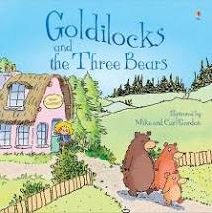  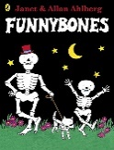  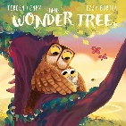  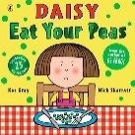  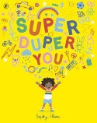  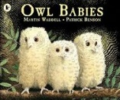 | 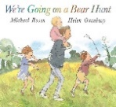  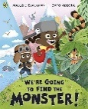  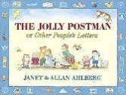  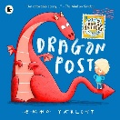  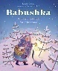 | 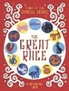 | 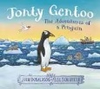  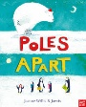 | 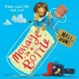  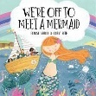  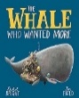  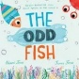 | 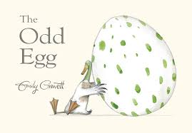  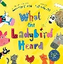  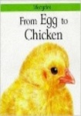  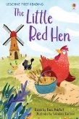  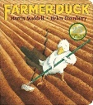 | 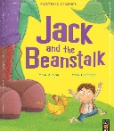  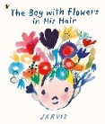  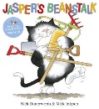  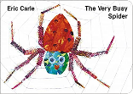  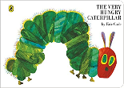
Literacy -  Reading | Oxford Reading Tree stories  Fiction – recognising familiar characters and relating to who is in our family. Reliving everyday experiences and talking about past and present events.  Super Duper You  Fiction – Discussion text - what do we like? What don’t we like? Who are we?  Daisy Eat your Peas – Fiction – repetitive language. Reading with rhythm and recognising repeated refrains.  Goldilocks and the Three Bears  Fiction – Traditional tales  identifying features/characters of the story.  Owl Babies Fiction – Repetitive language, sequencing the events.  Discussion text – drama.  The Wonder Tree  Fiction – comparison story to The Owl Babies.  Funny Bones  Fiction – repetitive and rhythmic language. | We’re Going on a Bear Hunt / We’re Going on a Monster Hunt  Fiction – Repetitive language Collaborative group work idea generation for a new chapter of a familiar story.  Dragon Post  Fiction – persuasion text, discuss the language used to persuade. Features of letters.  Jolly Postman  Fiction – Familiar settings and characters  Babushka – Comparison story to the Jolly Postman. Look for similarities and differences across the stories. | The Great Race: The Story of the Chinese Zodiac (Fantasy/Journey story)  Fiction – sequencing events. Recognising stories from the past and traditional tales from other countries. | Pole Apart  Fiction – journey story.  Travelling to different places. Discussions around descriptive language.  Jonty Gentoo  Fiction – Journey story - compare to Poles Apart. Rhythm and rhyme story.  Polar Bear Fact file - TFW  Information text – facts around an animal. Grouping facts into categories. | Message in a Bottle –  Discussion text – what would we like in a friend? Advert for a friends  We’re off to meet a mermaid  Fiction – rhythm and rhyme story, join in with repeated refrains.  The Odd Fish  Fiction –persuasion - look after our seas  Link to non-fiction explanation texts around protecting the animals and oceans.  The Whale who wanted more  Fiction – discussion text – being a good friend | Egg to Chicken  Non-fiction – Information texts, fact file for Chicken  – explanation - diary of the life cycle  Non-fiction – explanation – observations of chicks  Little Red Hen  Fiction – Places with familiar settings  SEMH – managing feelings and behaviour  Farmer Duck  Fiction – Sequencing and retelling a story.  What the Ladybird Heard  Fiction text – familiar setting, rhythm and rhyme story. | The Very Hungry Caterpillar by Eric Carle  Fiction – sequencing – days of the week  Non-fiction – explanation – life cycle of a caterpillar  Jack and the Beanstalk  Fiction – traditional Tales  Jaspers Beanstalk  Fiction – sequencing – days of the week, compare to The Very Hungry caterpillar and the use of days.  TFW – The Very Busy Spider –  Recall and retell the story using actions and words. Stories from familiar authors.
Phonological Awareness | - Hear environmental sounds.  - Identify rhythm and rhyme.  - Hear initial sounds.  - Orally blend simple words.  - Segment simple words orally  Level 1+ sounds  s, a, t, p, i, n, m, d, g, o, c, k, ck, e, u, r, h, b, f, ff, l, ll, le, ss |  | - Hear and record initial sounds.  - Record final sounds.  - Write many CVC words independently.  - Use taught digraphs where appropriate.  - Segment words to spell.  Level 2 sounds  j, v, w, x, y, z, zz, qu, ch, sh, th, ng, dge, ,ve, wh, cks, tch, nk, ai |  |  | - Apply phonics independently.  - Write recognisable words.  - Spell many common exception words.  - Spell words using known graphemes.  - Self-correct where appropriate.  Level 3 sounds  ee, igh, oa, oo, oo, ar, or, ur, ow, oi, ear, air, er, er, ue, ue, ure, ture
Squiggle Whilst you Wiggle | Move 1 – up and down, left and right, criss cross  Move 2 – up wiggle, down wiggle, left wriggle, right wriggle, cross over wiggle.  Move 3 – The Circles, left side, right side  Movements linked to letter formation ( ilt) ( coad) | Move 4 – The hump left and right, split the hump left and right,move the hump left and right, under the hump left and right, split the under hump left and right, moce the under hump left and right,Movements linked to letter formation ( mnru) | Move 5 – The hook up left and right,the downward hook left and right,  Move 6 – Spiral down and up, spiral left and right, Move 7 - wave down and up, horizontal wave left and right,horizontal wave crossing over.  Movements linked to letter formation ( e,q,p,h,k,b,y,g,I,f) |  | Move 8 - laid down 8, stand 8 up.  Move 9 – Straight line down and up left and right ( stairs)Movements linked to letter formation (svwxz)
Literacy - Writing | - Hold pencils with increasing control.  - Begin to use an efficient pencil grip.  - Develop correct seated posture.  - Make purposeful marks.  - Give meaning to marks.  - Draw representations with increasing detail.  - Use marks during role play.  - Understand that print carries meaning. | - Write their own name.  - Begin forming recognisable letters.  - Attempt labels.  - Write initial sounds in words.  - Use phonetically plausible spellings. Talk about ideas before writing.  - Draw and talk about pictures.  - Dictate simple sentences.  - Share meanings with adults. | Form taught letters correctly.  Start letters in the correct place.  Maintain consistent letter size.  Leave finger spaces between words with support  Write short phrases and captions.. |  | Compose simple sentences orally.  Write captions independently.  Write simple sentences.  Include spaces between words.  Attempt to us capital letters and full stops. | - Sequence ideas logically.  - Re-read writing.  - Add detail through discussion.  - Write for different purposes including:  - labels  - captions  - lists  - simple messages  - story writing | Write with increasing stamina.  Sustain writing independently.  Record ideas confidently.  Use writing across all areas of learning.
Writing links to focus stories or themes.  Drawing club to run alongside. | Potion writing (segmenting to write words, write initial sounds)  Making birthday cards for peers / family. | We’re going on a bear hunt  Adult to scribe the new verse of the story  Write a list to Father Christmas | The Chinese Zodiac Story  Retelling the story of the Lunar New Year - write sentence to match each picture.  Writing in a list ( Chinese menu) to go with our banquet | TFW – Polar Bear Fact File  Labelling a picture of a polar bear  Writing key facts to explain what we know about an animal | Message in a Bottle  Advert for a friend. What would a friend need to be?  We’re off the meet a mermaid  Label a mermaid – descriptive writing. What will the mermaid be like? | Egg to Chicken  Chick observations, label a diagram. Writing facts about chickens / eggs  Farmer Duck ( change story)  Descriptive writing – what would the duck do? Write another job for the duck based on the story | Jasper’s Beanstalk  Instruction texts – write a set of instructions on how to plant a seed to grow a plant.  The Very Hungry Caterpillar –  Sequencing and retelling. Re write a familiar story.
Mathematics (number) | - Match sort and compare – matching, identifying sets, sorting and comparing amounts  - It’s me 1, 2, 3 – find, subitise, represent and composition of 1, 2 and 3  - 1, 2, 3, 4, 5 - find, subitise, represent and composition of 4 and 5 |  | - Alive in 5 – introduce 0, find, subitise, represent and composition of 0-5  - Growing 6, 7, 8 – find, represent and composition of 6, 7 and 8, make pairs, double to 8, combining 2 groups (adding)  - Building 9 and 10 – find, compare, represent, subitise and composition to 10, making bonds to 10, doubles to 10 and exploring even and odd. |  |  | - To 20 and beyond – build numbers beyond 10, continue patterns beyond 10, verbal counting beyond 20, verbal counting patterns  - How many now? – add more, how many did I add? Take away, how many did I take away?  - Sharing and Grouping – sharing, grouping, even and odd sharing, play and build doubles  - Make connections – deepen understanding, patterns and relationships.
Mathematics (measure, shape and spatial reasoning) | - Talk about measure and patterns - Comparing size, mass & capacity; exploring pattern  - Circles and Triangles – identify and compare circles and triangles, shapes in the environment and position  Shapes with 4 sides – identify, name and combine shapes with 4 sides, shapes in the environment, my day and night |  | - Mass and Capacity – compare mass, balance, explore and compare capacity  - Length, height and time – explore and compare length and height, talk about, order and sequence time. |  |  | - Explore 3D shapes – recognise and name 3D shapes, find 2D shapes within 3D shapes, 3D shapes in the environment, identify complex patterns, copy and continue patterns, look for patterns in the environment.  - Manipulate, compose and decompose – select shapes for purples, rotate and manipulate shapes and explain arrangements, compose and decompose shapes, find 2D shapes within 3D shapes.  - Visualise, build and map - identify units of patterns, create and explore own patterns, visualise from different positions, describe positions, give instructions to build, create own maps.
Physical Development | Games  - Introduction to PE  - Gross Motor development – running, hopping, jumping,  - Ball skills | Dance  - Gross Motor development  -balancing, skipping, turns etc. | Gymnastics / Fundamental skills  - Making different shapes with our bodies  - Practise balancing  - Jumping and landing. |  | Gymnastics and Target games  - Travelling around and through apparatus  - Jumping and landing from a height  - Throwing with accuracy | Games / Invasion games  - Understanding game rules  - Working as part of team  - Helping team mates | Ball Skills / Athletics  - Throwing and catching  - Moving with a ball  - Developing accuracy in all skills learnt over the year
Physical Development  Fine Motor Skills | Develop hand, finger and wrist strength through malleable materials, construction, threading, peg activities and mark-making.  Develop hand-eye coordination, two-handed control and a comfortable pencil grip. | Develop greater control and precision when using pencils, scissors, tweezers, paintbrushes and other small tools. Begin to cut along lines, manipulate smaller objects and develop a consistent hand preference. | Refine dexterity and accuracy. Use one hand to stabilise while the other works. Develop controlled drawing, cutting, threading, construction and modelling skills, alongside increasing independence in self-care. |  | Develop effective pencil control for writing. Form controlled patterns, shapes and letters, with increasing accuracy and appropriate pencil grip. Use scissors and other tools confidently and safely. | Apply fine motor skills across the curriculum with increasing precision and independence. Develop detailed drawing, modelling, construction, cutting and writing skills. | Consolidate fine motor control and independence in preparation for Year 1. Hold a pencil effectively, use a range of small tools competently, demonstrate accuracy and care in drawing, and manage practical/self-care tasks independently.
Understanding the World  (History) | - Families  - Talk about people around me and events that have already happened | - Comparing characters in Christmas stories | - Great wall of China  - The history of the Lunar New Year and why it is celebrated | - Why the Innuits built Inukshuks.  - What was life like living in the Arctic – compare live now and in the past. | - Looking at images of the seaside from the past and comparing to seasides today. | - Looking at images of farming from in the past, compare to farming today.
Understanding the World (Geography) | - Explore the local area – local buildings and structures that are familiar to us.  - Where do we live?  - Look for signs of autumn | - Look at simple maps and route simple journeys to familiar places. | - Look at simple maps  - Look for signs of winter  - Comparing and contrasting places and environments based on non-fiction and maps. | - Look at simple maps  - Comparing and contrasting places and environments based on non-fiction and maps. | - Comparing and contrasting places and environments based on non-fiction and maps.  - Compare and contrast places to where I live. | - Look at simple maps  - Look for signs of spring/summer  - Describe their own environment.
RE | - Who belongs in my family and my community? Pathway 4 | - Who cares for me and how do I help others?  Pathway 3 | - Which places are special to members of our community? Pathway 1 |  | - Why are some objects special?  Pathway 2 | - How to people celebrate special times? Pathway 5 | - How do we understand and care for the world? Pathway 6
Expressive Arts and Design  Singing with Mrs Elwis | - Scissor control – using scissors safely  - Singing familiar nursery rhymes  - Recognising primary colours  - Drawing representations – self portraits – drawing lines and circles  Artist study – Mondrian – colours | - Scissor control – cutting along a predetermined line  - Learning new songs - singing along to a piano  - Mixing primary colours to make new colours  - Drawing skills – drawing lines, circles and other shapes.  Jackson Pollock – Dripping paint in different colours | - Using shapes to create pictures – Polar bear art.  - Adding white and black to change the shade of a colour.  - Using thick and thin paintbrushes to make different stokes – make Chinese symbols | - Looking at art work from the past and how it tells a story ( Willow pattern) using thick and thin brushstrokes  - Using different materials and media to create effects - collage | - Using different materials and media to create effects – printing with sponges/vegetables and different materials to create an effect.  - Using water colour to create pictures.  - Develop observational drawing skills  Artist study – Alfred Wallis | - Using different materials and media to create effects.  - Reviewing work and discussing how this could be improved  - Develop observational drawing skills  - Mixing shades using light and dark.  Artist Study -Vincent Van Gogh | - Using art to make symmetrical paintings. Printing skills using objects and paint.  Artists study – Matisse – collage
Design and Technology | Food Technology  - Trying toppings/flavours of porridge.  - Decorating a biscuit | - Christmas Hats – making joins using Sellotape, glue and staples.  Food Technology  - Melting chocolate and exploring reversible changes in food. | - Chinese Dragons – folding paper and card to make a spring.  Food Technology  - Reviewing food at the Chinese banquet  - Making an ice lolly – frozen fruit |  | Food Technology  Baking biscuits – rolling cutting skills | Making joins with split pins to show a moving mechanism  Food technology  Making bread | Threading – Spider Webs
Computing | Busy Bodies  - Looking at patterns  - Algorithms  - Logic  - Abstraction  - Debugging  - Decomposition | Awesome Autumn  - Creating  - Pattern  - Logic  - Algorithms  - Decomposition  - Collaborating | Winter Warmers  - Algorithms  - Creating  - Collaboration  - Decomposition  - Tinkering  - Persevering |  | Spring time  - Abstraction  - Tinkering  - Creating  - Collaborating  - Algorithms  - Persevering  - Decomposition | Summer Fun  - Tinkering  - Persevering  - Patterns  - Logic  - Decomposition  - Debugging  - Collaborating  - Algorithms | Super Space  - Algorithms  - Collaboration  - Persevering  - Creating  - Pattern  - Logical Reasoning  - Tinkering  - Abstraction

